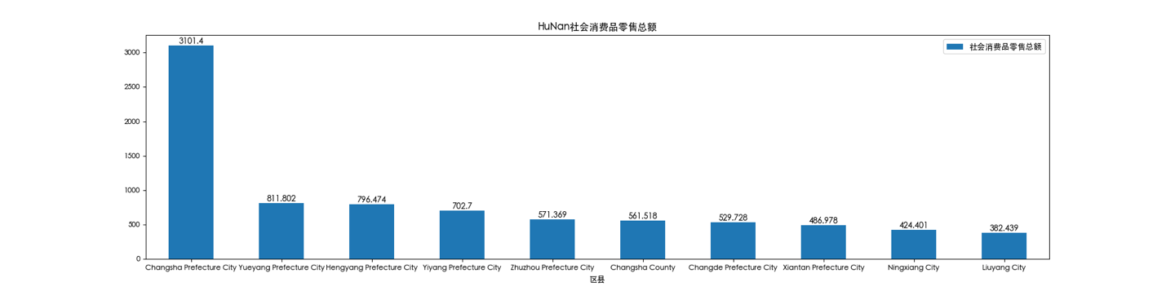

反应局面消费水平，福建省内top10差距最小。

大部分省份有一个特大城市，少数有两个比如山东